**Practical No.2: Implementing Classification in Weka(Decision Tree)**

* In this chapter, we will learn how Weka’s decision tree feature helps to classify unknown samples of a dataset based on its attribute values.
* When Weka’s decision tree is applied to an unknown sample, the decision tree classifies the sample into different classes such as Class A, Class B and Class C as shown in Figure

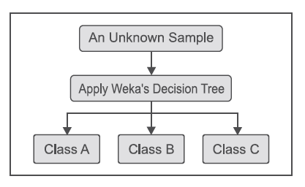

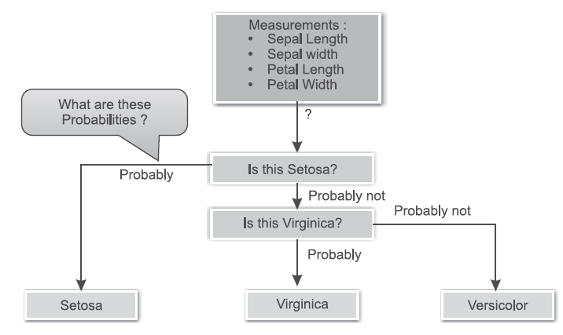

**Steps to take when applying the decision tree classifier on the Iris**

**dataset in Weka**

1. Start ***Weka Explorer*** and go to the ***Preprocess*** tab.

2. Under ***Open File*** tab, select the data source as given in Figure



3. Move from the ***Preprocess*** tab to the ***Classify*** tab. To select the Weka J48 algorithm, click on

***Choose***. Then follow the path:

Weka -> classifiers -> trees -> J48

After selecting J48, click ***Close*** to return to the ***Classify*** tab as shown in below Figure



4.

After loading the J48 decision tree, left-click on J48 to open up the Weka ***Generic Object Editor****.*

For our first try to build a decision tree, we will accept all of the defaults here, except that we

will change ***saveInstanceData*** to ***true***. This will allow us to find out how each iris sample is

classified after building the tree. By clicking ***More***, you can find further information on the

items.



Select ***Percentage split*** from test options as shown in Figure 6.7. Keep default value 66%. It

means 66% records, i.e., 2/3 of records from whole Iris dataset (containing 150 records), will

be used for training purpose and remaining records in the dataset will be used for testing

purpose. Since the Iris dataset has a total of 150 records, 99 records will be used for training

the decision tree model, while the remaining 51 records will be used to test the decision tree







6.

Now we are ready to run the J48 decision tree learner. Click ***Start*** on the ***Classify*** tab as shown

in Figure 6.10. The ***Classifier output*** box shows the results of classification. The portion of

the ***Classifier output*** box seen here verifies that we have analyzed the correct dataset.



The classifier’s accuracy statistics can be found in the classifier output section as shown in Figure



7. To see the tree, right-click on the highlighted ***Result list*** entry for the tree we just built, and

then click ***Visualize tree*** as shown in Figure



Finally, we have our long-awaited decision tree for our Fisher’s Iris Dataset. As given in Figure

6.13 you can see that it is quite easy to read.

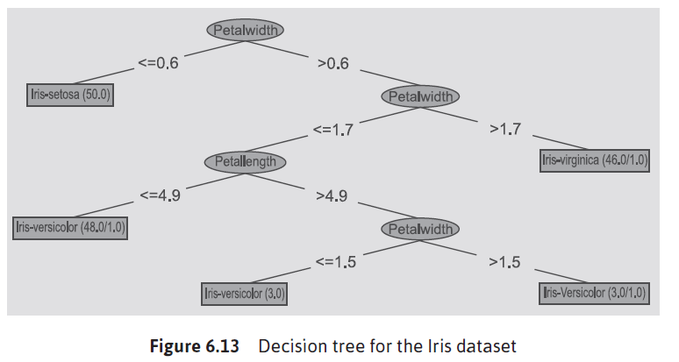

**Understanding the confusion matrix**

There are a total of 51 instances for which we have tested using J48. Of these, the confusion matrix

shown in Figure 6.14, tells us that us that J48 properly classified 15 Setosa, 19 Versicolor and 15

Virginica. However it classified incorrectly, 2 Virginica as Versicolor as shown in Figure 6.14.



**Understanding the decision tree**

Starting at the top of the tree, it says that if Petal width is less than or equal to 0.6 cm, then

the Iris species is Setosa as shown in Figure 6.15.



**Reading decision tree rules**

Weka also produces the decision tree structure in terms of rules. Scroll through the ***Classifier output***

box on the ***Classify*** tab to find the rules that govern the tree as shown in Figure 6.18.



**Interpreting results**

We see that the tree has 5 leaves, and that the total size of the tree is 9 elements as shown in Figure

6.20.



|  |
| --- |
| Implementation of Decision Tree using Python. |
| *# Decision tree # Q. Write a program to implement Decision Tree and Random forest with Prediction, Test Score and Confusion Matrix.* import pandas as pd from sklearn.model_selection import train_test_split from sklearn.tree import DecisionTreeClassifier from sklearn.metrics import confusion_matrix, accuracy_score, classification_report   *# Read Datasets* def read_datasets():  datasets = pd.read_csv("https://archive.ics.uci.edu/ml/machine-learning-databases/balance-scale/balance-scale.data",  sep=",", header=None)  print(f"Dataset Length : {len(datasets)}")  print(f"Dataset Shape: {datasets.shape}")  print(f"Datasets : {datasets.head()}")   return datasets  *# Spliting Datasets into train and test* def splitdataset(datasets):  X = datasets.values[:, 1:5]  Y = datasets.values[:, 0]   X_train, X_test, y_train, y_test = train_test_split(X, Y, test_size=0.3, random_state=100)  *# print(f"x_train:{X_train}\n x_test: {X_test}\n y_train: {y_train}\n y_test: {y_test}")* return X_train, X_test, y_train, y_test   def train_using_gini(X_train, y_train):  clf_gini = DecisionTreeClassifier(criterion='gini', random_state=100, max_depth=3, min_samples_leaf=5)   clf_gini.fit(X_train, y_train)  return clf_gini   def train_using_entropy(X_train, y_train):  clf_entropy = DecisionTreeClassifier(criterion='entropy', random_state=100, max_depth=3, min_samples_leaf=5)   clf_entropy.fit(X_train, y_train)  return clf_entropy   def prediction(X_test, clf_object):  y_pred = clf_object.predict(X_test)  print(f"Predicted values: {y_pred}")  return y_pred   def cal_accuracy(y_test, y_pred):  print(f"Confusion Metrix :{confusion_matrix(y_test, y_pred)}")  print(f"Accuracy: {accuracy_score(y_test, y_pred) * 100}")  print(f"Report: {classification_report(y_test, y_pred)}")   def main():  datasets = read_datasets()  X_train, X_test, y_train, y_test = splitdataset(datasets)  clf_gini = train_using_gini(X_train, y_train)  clf_entropy = train_using_entropy(X_train, y_train)   print("Results using Gini Index: ")  y_pred_gini = prediction(X_test, clf_gini)  cal_accuracy(y_test, y_pred_gini)   print("Results using Entropy Index: ")  y_pred_entropy = prediction(X_test, clf_entropy)  cal_accuracy(y_test, y_pred_entropy)   if __name__ == "__main__":  main()  Output: |